**LAB TASK 5 WITH SOLUTIONS**

**1.[Write a C program to create, initialize and use pointers](https://codeforwin.org/2017/01/c-program-to-demonstrate-use-of-pointers.html).**

**#include <stdio.h>**

**int main()**

**{**

**char ch;**

**char *pCh;**

**pCh = &ch;**

**ch = 'A';**

**printf("Value of ch: %c\n",ch);**

**printf("Address of ch: %p\n",&ch);**

**printf("Value of ch: %c\n",*pCh);**

**printf("Address of ch: %p",pCh);**

**return 0;**

**}**

**Output:**

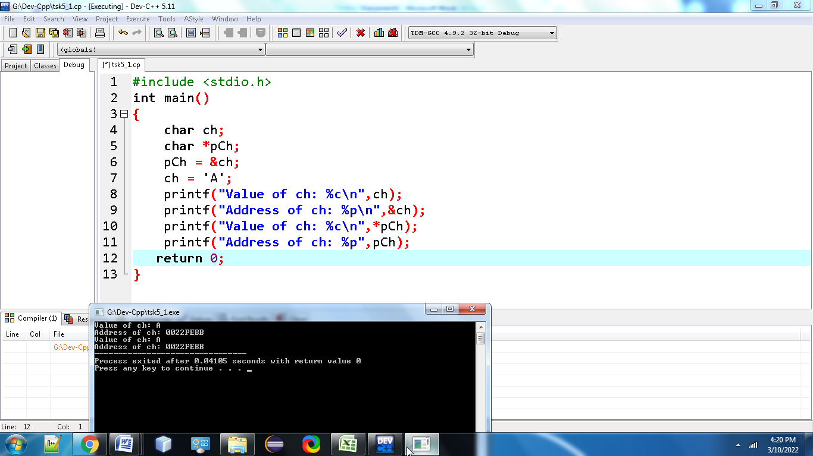

1. [**Write a C program to add two numbers using pointers**](https://codeforwin.org/2017/01/c-program-to-add-two-numbers-using-pointers.html)**.**

**#include <stdio.h>**

**int main()**

**{**

**int first, second, *p, *q, sum;**

**printf("Enter two integers to add\n");**

**scanf("%d%d", &first, &second);**

**p = &first;**

**q = &second;**

**sum = *p + *q;**

**printf("Sum of entered numbers = %d\n",sum);**

**return 0;**

**}**

**Output:**

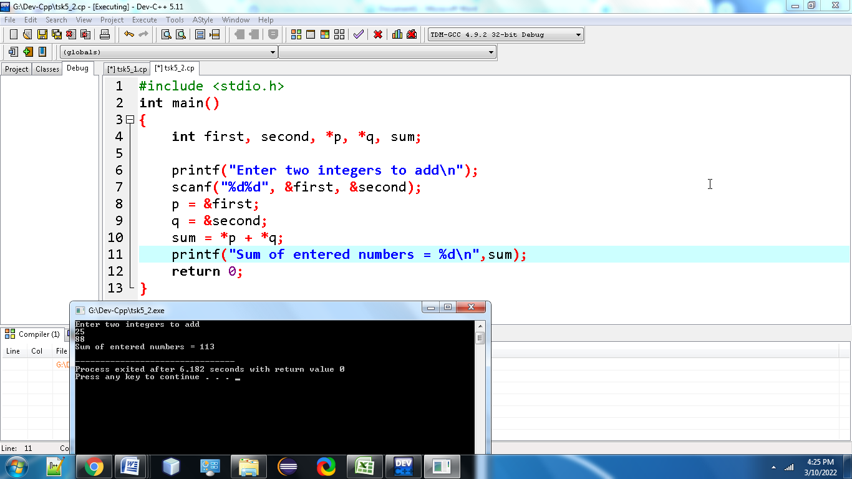

**3.** [**Write a C program to swap two numbers using pointers**](https://codeforwin.org/2017/01/c-program-to-swap-two-numbers-using-call-by-reference.html)**.**

**#include <stdio.h>**

**void swap(int *x,int *y)**

**{**

**int t;**

**t = *x;**

**\*x = *y;**

**\*y = t;**

**}**

**int main()**

**{**

**int num1,num2;**

**printf("Enter value of num1: ");**

**scanf("%d",&num1);**

**printf("Enter value of num2: ");**

**scanf("%d",&num2);**

**printf("Before Swapping: num1 is: %d, num2 is: %d\n",num1,num2);**

**swap(&num1,&num2);**

**printf("After Swapping: num1 is: %d, num2 is: %d\n",num1,num2);**

**return 0;**

**}**

**Output:**

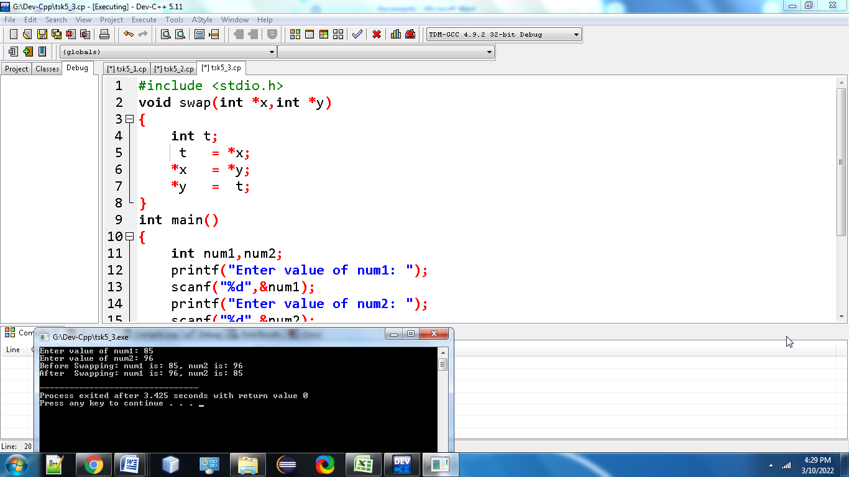

**4)** [**Write a C program to input and print array elements using pointer**](https://codeforwin.org/2017/11/c-program-input-print-array-elements-using-pointers.html)**.**

**#include <stdio.h>**

**#define MAX_SIZE 100**

**int main()**

**{**

**int arr[MAX_SIZE];**

**int N, i;**

**int * ptr = arr;**

**printf("Enter size of array: ");**

**scanf("%d", &N);**

**printf("Enter elements in array:\n");**

**for (i = 0; i < N; i++)**

**{**

**scanf("%d", ptr);**

**ptr++;**

**}**

**ptr = arr;**

**printf("Array elements: ");**

**for (i = 0; i < N; i++)**

**{**

**printf("%d, ", *ptr);**

**ptr++;**

**}**

**return 0;**

**}**

**Output:**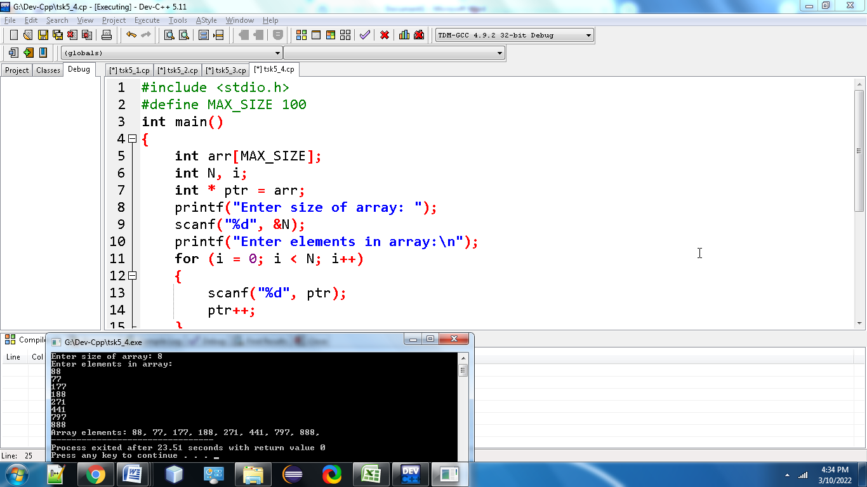

**5.** [**Write a C program to copy one array to another using pointers**](https://codeforwin.org/2017/11/c-program-to-copy-one-array-to-another-using-pointers.html)

**#include <stdio.h>**

**#define MAX_SIZE 100**

**void printArray(int arr[], int size);**

**int main()**

**{**

**int source_arr[MAX_SIZE], dest_arr[MAX_SIZE];**

**int size, i;**

**int *source_ptr = source_arr;**

**int *dest_ptr = dest_arr;**

**int *end_ptr;**

**printf("Enter size of array: ");**

**scanf("%d", &size);**

**printf("Enter elements in array: ");**

**for (i = 0; i < size; i++)**

**{**

**scanf("%d", (source_ptr + i));**

**}**

**end_ptr = &source_arr[size - 1];**

**printf("\nSource array before copying: ");**

**printArray(source_arr, size);**

**printf("\nDestination array before copying: ");**

**printArray(dest_arr, size);**

**while(source_ptr <= end_ptr)**

**{**

**\*dest_ptr = *source_ptr;**

**source_ptr++;**

**dest_ptr++;**

**}**

**printf("\n\nSource array after copying: ");**

**printArray(source_arr, size);**

**printf("\nDestination array after copying: ");**

**printArray(dest_arr, size);**

**return 0;**

**}**

**void printArray(int *arr, int size)**

**{**

**int i;**

**for (i = 0; i < size; i++)**

**{**

**printf("%d, ", *(arr + i));**

**}**

**}**

**Output:**

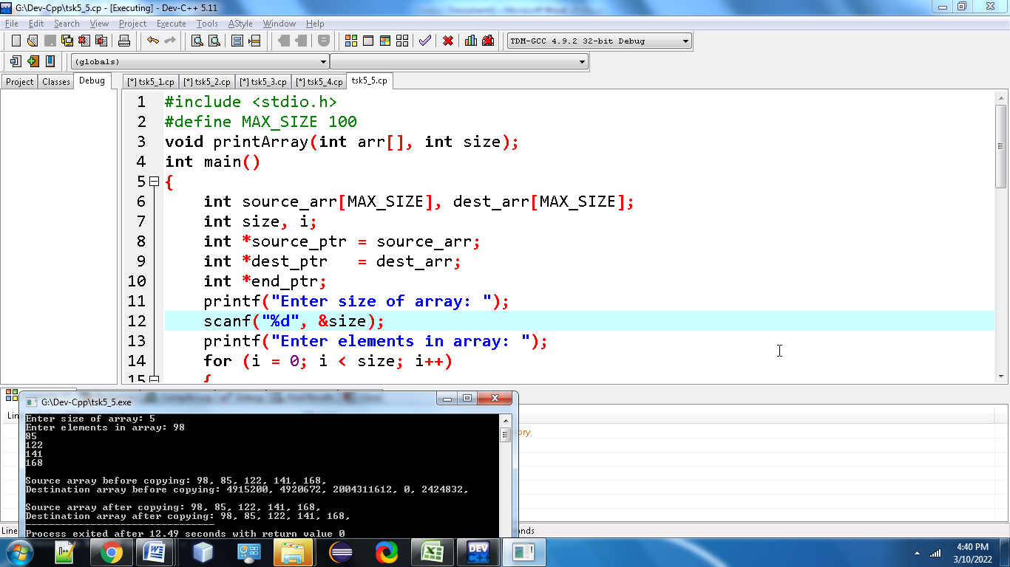

**6.** [**Write a C program to swap two arrays using pointers**](https://codeforwin.org/2017/11/c-program-to-swap-two-arrays-using-pointers.html)**.**

**#include <stdio.h>**

**#include <stdlib.h>**

**void swapTwoArrays(int *arr1, int *arr2, int n)**

**{**

**int i, temp;**

**for (i = 0; i < n; i++)**

**{**

**temp = *(arr1 + i);**

**\*(arr1 + i) = *(arr2 + i);**

**\*(arr2 + i) = temp;**

**}**

**return;**

**}**

**int main()**

**{**

**int *arr1, *arr2, i, j, n;**

**printf("Enter the order of the arrays:");**

**scanf("%d", &n);**

**arr1 = (int *) malloc(sizeof(int) * n);**

**arr2 = (int *) malloc(sizeof(int) * n);**

**printf("Enter data for first array:\n");**

**for (i = 0; i < n; i++)**

**{**

**printf("Array1[%d] : ", i);**

**scanf("%d", (arr1 + i));**

**}**

**printf("Enter data for second array:\n");**

**for (i = 0; i < n; i++)**

**{**

**printf("Array2[%d] :", i);**

**scanf("%d", arr2 + i);**

**}**

**swapTwoArrays(arr1, arr2, n);**

**printf("Elements in first array:\n");**

**for (i = 0; i < n; i++)**

**{**

**printf("%d ", *(arr1 + i));**

**}**

**printf("\n");**

**printf("Elements in second array:\n");**

**for (i = 0; i < n; i++)**

**{**

**printf("%d ", *(arr2 + i));**

**}**

**printf("\n");**

**return 0;**

**}**

**Output:**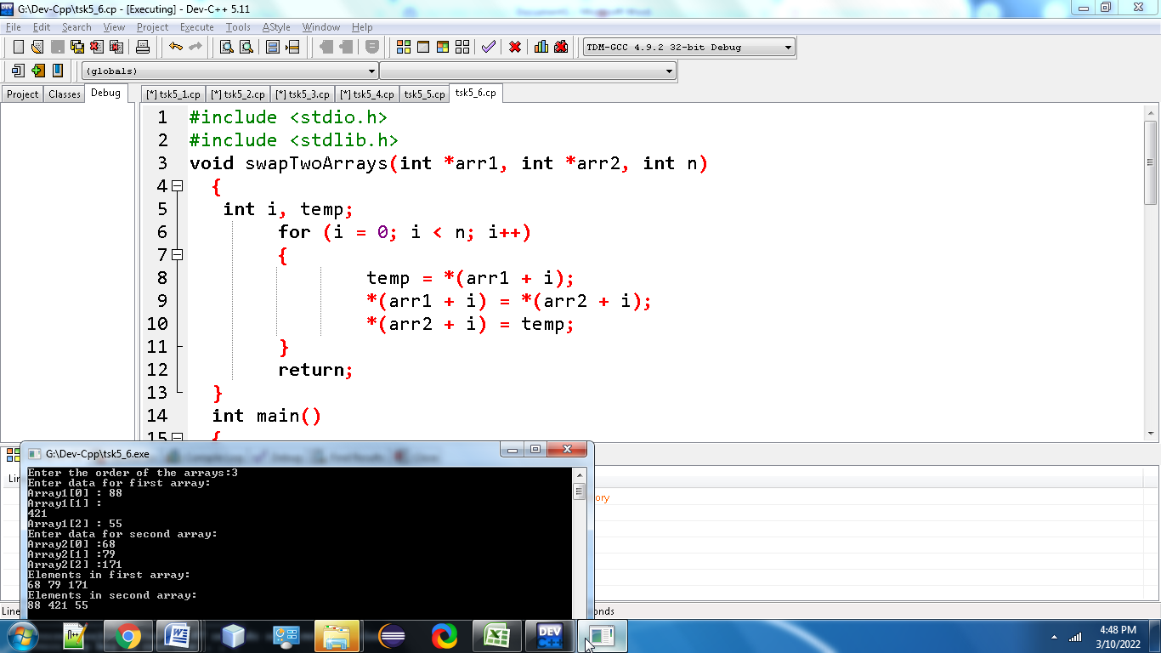

**7.Write a C Program to reverse an Array Using Pointers**

**#include <stdio.h>**

**#define MAX_SIZE 100**

**void printArr(int *arr, int size);**

**int main()**

**{**

**int arr[MAX_SIZE];**

**int size;**

**int *left = arr;**

**int *right;**

**printf("Enter size of array: ");**

**scanf("%d", &size);**

**right = &arr[size - 1];**

**printf("Enter elements in array: ");**

**while(left <= right)**

**{**

**scanf("%d", left++);**

**}**

**printf("\nArray before reverse: ");**

**printArr(arr, size);**

**left = arr;**

**while(left < right)**

**{**

**\*left ^= *right;**

**\*right ^= *left;**

**\*left ^= *right;**

**left++;**

**right--;**

**}**

**printf("\nArray after reverse: ");**

**printArr(arr, size);**

**return 0;**

**}**

**void printArr(int * arr, int size)**

**{**

**int * arrEnd = (arr + size - 1);**

**while(arr <= arrEnd)**

**{**

**printf("%d, ", *arr);**

**arr++;**

**}**

**}**

**Output:**

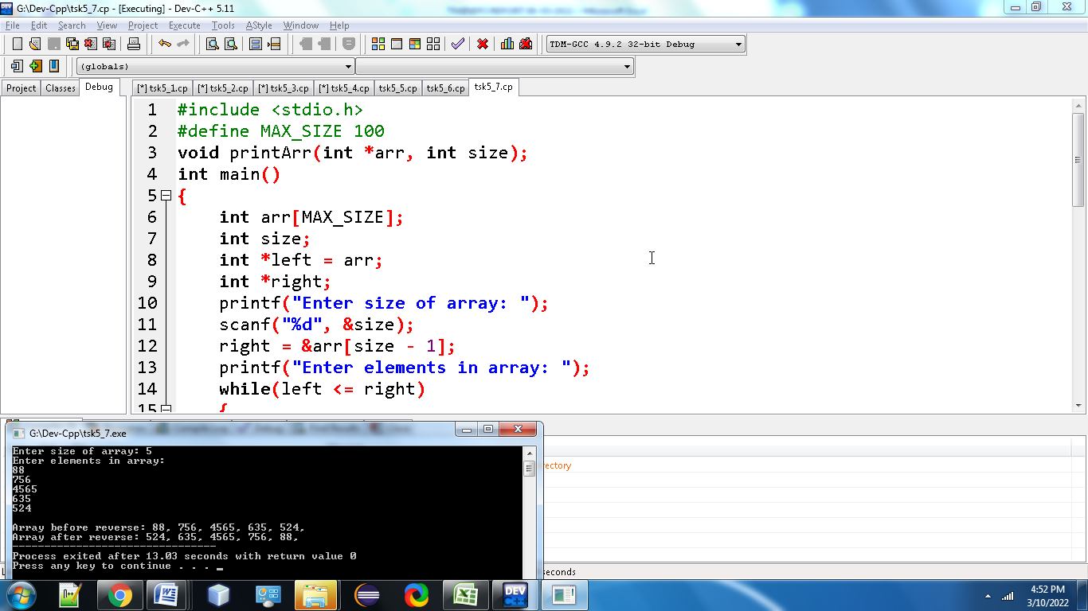

8. [Write a C program to find length of string using pointers](https://codeforwin.org/2015/04/c-program-to-calculate-length-of-string.html#program-using-pointer).

**#include<stdio.h>**

**#include<conio.h>**

**int string_ln(char*);**

**int main() {**

**char str[20];**

**int length;**

**printf("\nEnter any string : ");**

**gets(str);**

**length = string_ln(str);**

**printf("The length of the given string %s is : %d", str, length);**

**return 0;**

**}**

**int string_ln(char*p)**

**{**

**int count = 0;**

**while (*p != '\0') {**

**count++;**

**p++;**

**}**

**return count;**

**}**

**Output:**

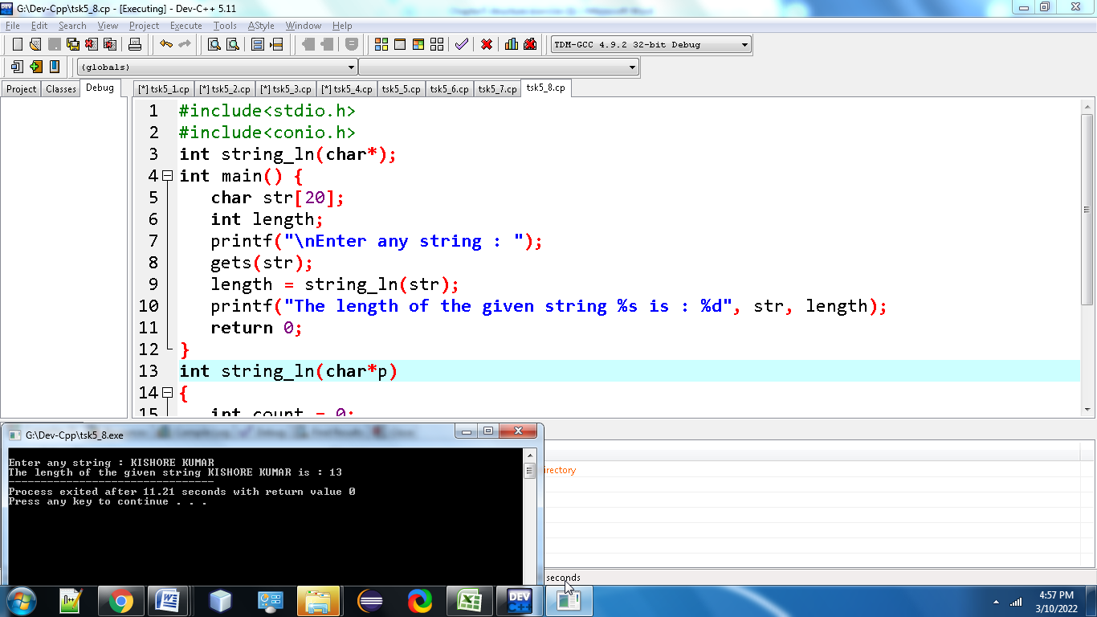

**9.** [**Write a C program to copy one string to another using pointers**](https://codeforwin.org/2015/11/c-program-to-copy-one-string-to-another.html#program-using-pointer)**.**

**#include<stdio.h>**

**void copystr(char*,char*);**

**int main()**

**{**

**char*str1="OLD IS GOLD";**

**char str2[30];**

**copystr(str2,str1);**

**printf("\n %s",str2);**

**return 0;**

**}**

**void copystr(char *dest,char *src)**

**{**

**while(*src!='\0')**

**\*dest++=*src++;**

**\*dest='\0';**

**return;**

**}**

**Output:**

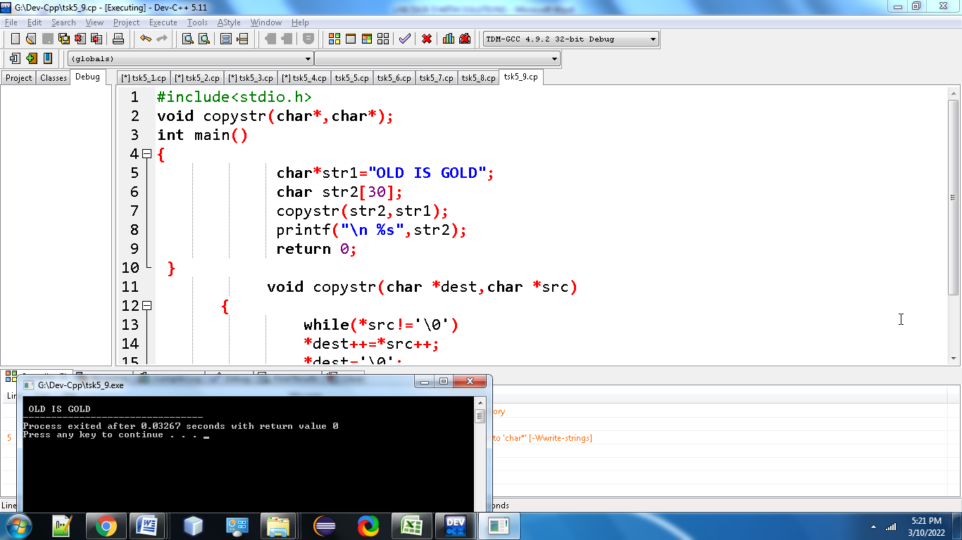

**10.** [**Write a C program to concatenate two strings using pointers**](https://codeforwin.org/2015/11/c-program-to-concatenate-two-strings.html#program-using-pointer)**.**

**#include <stdio.h>**

**#define MAX_SIZE 100 // Maximum string size**

**int main()**

**{**

**char str1[MAX_SIZE], str2[MAX_SIZE];**

**char * s1 = str1;**

**char * s2 = str2;**

**printf("Enter 1st string: ");**

**gets(str1);**

**printf("Enter 2nd string: ");**

**gets(str2);**

**while(*(++s1));**

**while(*(s1++) = *(s2++));**

**printf("Concatenated string: %s", str1);**

**return 0;**

**}**

**Output:**

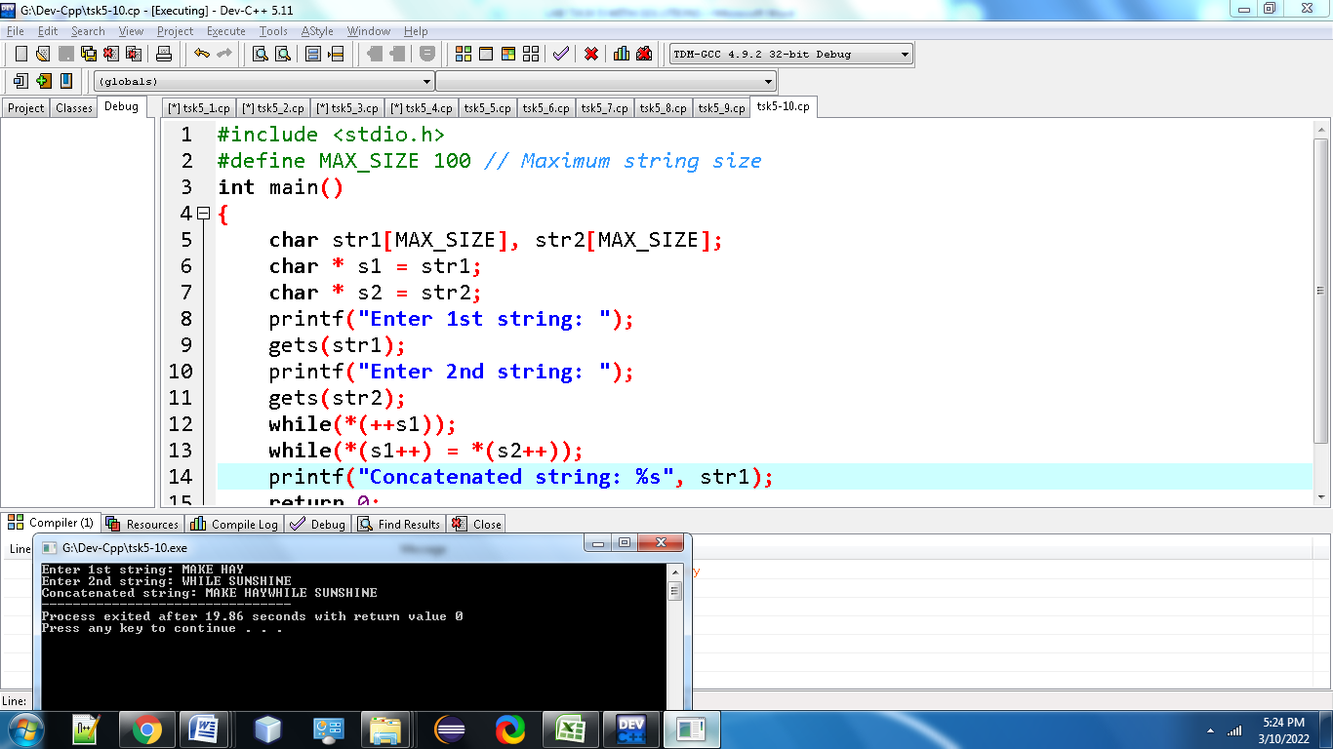

**11.** [**Write a C program to compare two strings using pointers**](https://codeforwin.org/2015/11/c-program-to-compare-two-strings.html#program-using-pointer)**.**

**#include<stdio.h>**

**int main()**

**{**

**char string1[50],string2[50],*str1,*str2;**

**int i,equal = 0;**

**printf("Enter The First String: ");**

**scanf("%s",string1);**

**printf("Enter The Second String: ");**

**scanf("%s",string2);**

**str1 = string1;**

**str2 = string2;**

**while(*str1 == *str2)**

**{**

**if ( *str1 == '\0' || *str2 == '\0' )**

**break;**

**str1++;**

**str2++;**

**}**

**if( *str1 == '\0' && *str2 == '\0' )**

**printf("\n\nBoth Strings Are Equal.");**

**else**

**printf("\n\nBoth Strings Are Not Equal.");**

**}**

**Output:**

